Community Services Committee

Chairperson Sylvia Wilson
Meeting Date: October 13, 2022 6:30 pm
Meeting Place Online

Call to Order: 6:33 pm
Committee member attendees: Sylvia Wilson, Carey Begbie Westerfield, Alex Reynolds, Theresa Torrance
Other NC member attendees: Heather Tuttle, Naomi Waka

Discussion/Action (Motion):

1. Presentation by Noah Fleishman (CD11) regarding 311 city services: website (myLA311.lacity.org), app (iPhone and android), and phone line, see something/say something, please report issues, over 1,200 city services available (some informational and some to create work tickets/requests), for example: business owners can report graffiti, ADA challenges, dumpster pickup, permits for al fresco dining, permits to install beautifications to front of businesses, contact CD11 office if issue isn’t resolved to satisfaction and they can give a nudge to the appropriate city service department
Theresa asked about using 311 for small businesses
Alex asked about removal of homeless people with 311

2. Discussion on Supporting the Small Business Community with local small business owners.

Business owners discuss challenges post pandemic: marketing, foot traffic, inconsistent sales, being flexible with business model changes, taking chances and trying new things, trouble hiring new employees (which affects meeting client demand and altering business offices)

Sara at Lily Love Boutique (8125 B W Manchester Ave. Playa Del Rey, California 90293)

Erin at Westchester Pharmacy (8930 S. Sepulveda Blvd Suite 103, Los Angeles, CA 90045)

Theresa read a statement by Just Massage (8329 Lincoln Blvd, Los Angeles, California 90045)
- Public Comment - Heather Tuttle (NCWP member) talked about the Ed Committee and possible partnerships between businesses and schools

3. Presentation and Discussion on Resources and Support for Small Businesses by Caroline Palacios (Economic and Workforce Development (EWDD) Specialist), https://ewddlacity.com
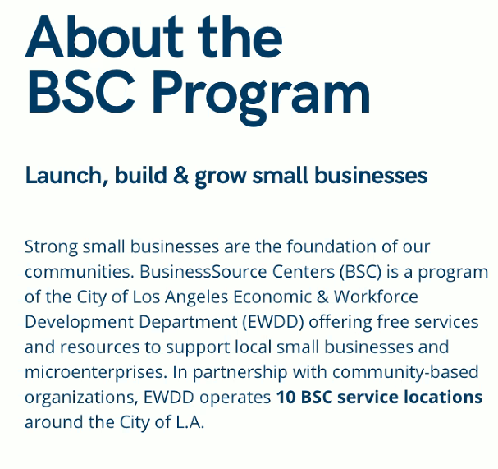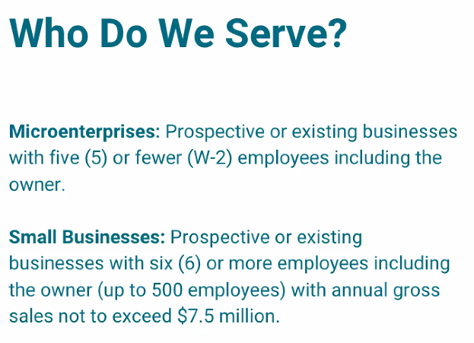
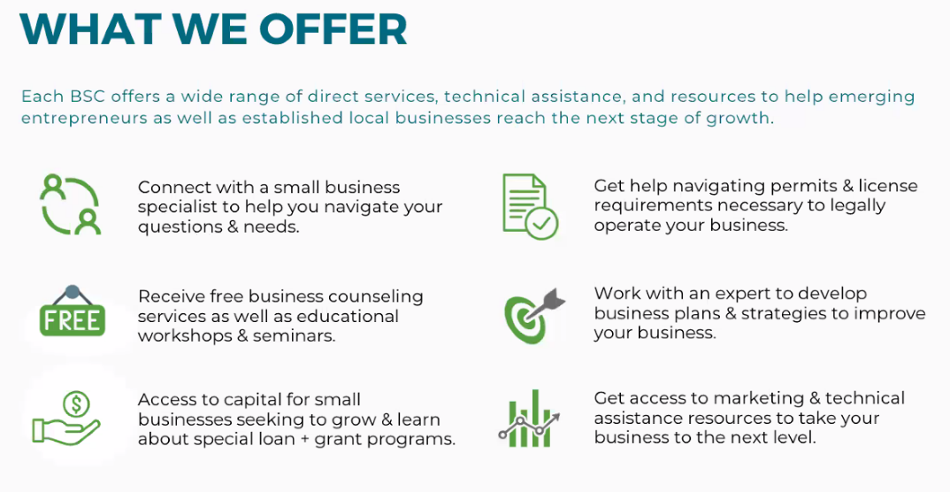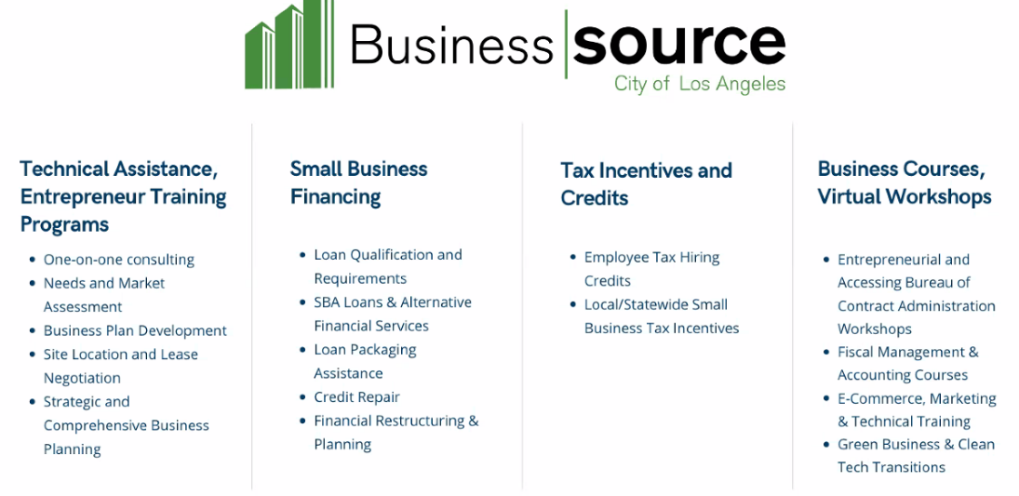
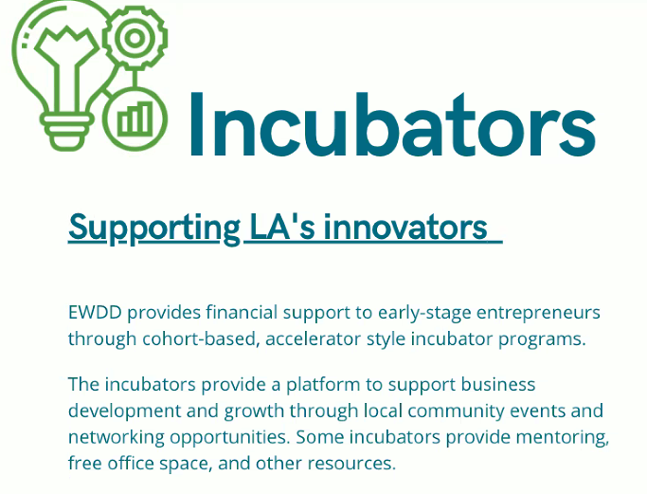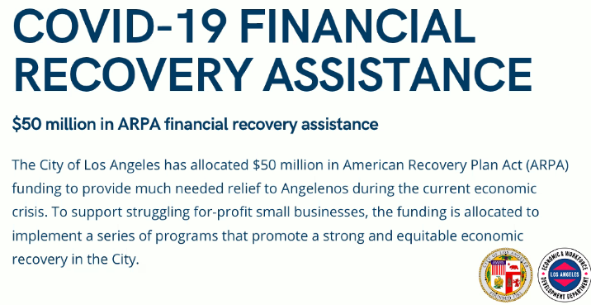
Other programs: microenterprise grants, equity fund, child care grant, child care support, legacy business recovery program, jobs and economic development incentive zones
- Committee Discussion
Theresa asked about the location of resource centers and receiving resources online (virtual meetings available)
Carey asked about non-for-profit businesses
Sylvia asked about CDFI microloans

4. Approval of the Minutes from the August 11, 2022 and September 8, 2022 meetings.
Motion made: Theresa Seconded: Carey
Motion passes

5. Presentation on the Westchester Recreation Center’s Fall Programming by Daisy Gomez (Recreation Coordinator): successful summer programs, fall sports started this week (flag football, girls volleyball, tiny flag football and soccer), fall classes (mixed media, karate, piano, ,double dutch, spooky science, winter crafts), camp available early Thanksgiving week, halloween events (Kid Zone and Rebirth: Park of Pain), multipurpose field is open
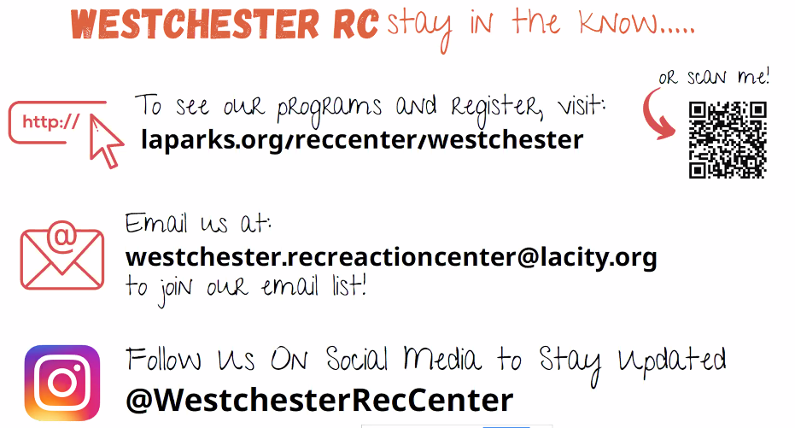
- Committee Discussion
Alex attended ribbon cutting for new fields past weekend
Sylvia asked about teen centered events (karate is 13+, afterschool leadership club for winter, fitness class for winter, resume building course in brainstorming process), suggested surveys for community members to help with teen programming
Theresa asked about marketing development/flier-making class for teen service jobs prior to resume class

Public Comment: Naomi Waka (NCWP member) thanked committee for having important community service providers present and the NPGs that come from this committee

Meeting adjourned: 8:16pm
Next Meeting- November 10, 2022

