Community Services Committee
Chairperson Sylvia Wilson
Meeting Date: May 12, 2022 6:30 pm
Meeting Place Online

Call to Order: 6:38pm

Committee members in attendance: Sylvia Wilson, Theresa Torrance, Alexandra Reynolds

Other NC members: Naomi Waka

Discussion/Action (Motion):

1.
Approval of Minutes from April 14, 2022 Meeting.
Theresa - made motion Alex - 2nd motion

2.
Discussion with Margaret Turner, Community Relations Coordinator, LAHSA and Jean Galiana, Older Adult Coodinator, LAHSA
Presentation by Maggie Turner and Jean Galiana on LAHSA’s SPA 5 Resources and Older Adult Resources in SPA 5.
Public Comment – Cristina Lovett
Committee Discussion – Theresa Torrance requested further information regarding Senior Contact information and how LAHSA’s Older Adult resources can assist the Westchester Senior Center in assisting those in our community who are seniors with housing insecurity. Sylvia Wilson requested information on tackling the biggest obstacles facing senior citizens in their transition to permanent housing and how to expedite the transition to permanent housing.

3.
Presentation and Discussion from Cristina Lovett, Recreation Coordinator, Westchester Senior Center on “Westchester Senior Center: Past, Present & Future.
Public Comment – Jean Galiana
Committee Discussion – Theresa Torrance asked about the possibility of the Center to use interactive or virtual events as a means to attract more local Seniors to utilize the Senior Center and provided information on how grants including Neighborhood Purposes Grants can provide the ability to finance equipment to put on virtual events. Sylvia Wilson requested information about how the community could provide support for interactive and virtual events.

4. Presentation and Discussion from Sylvia Wilson and Theresa Torrance on the city of Los Angeles’s Department of Aging’s Emergency Meal Program for Seniors.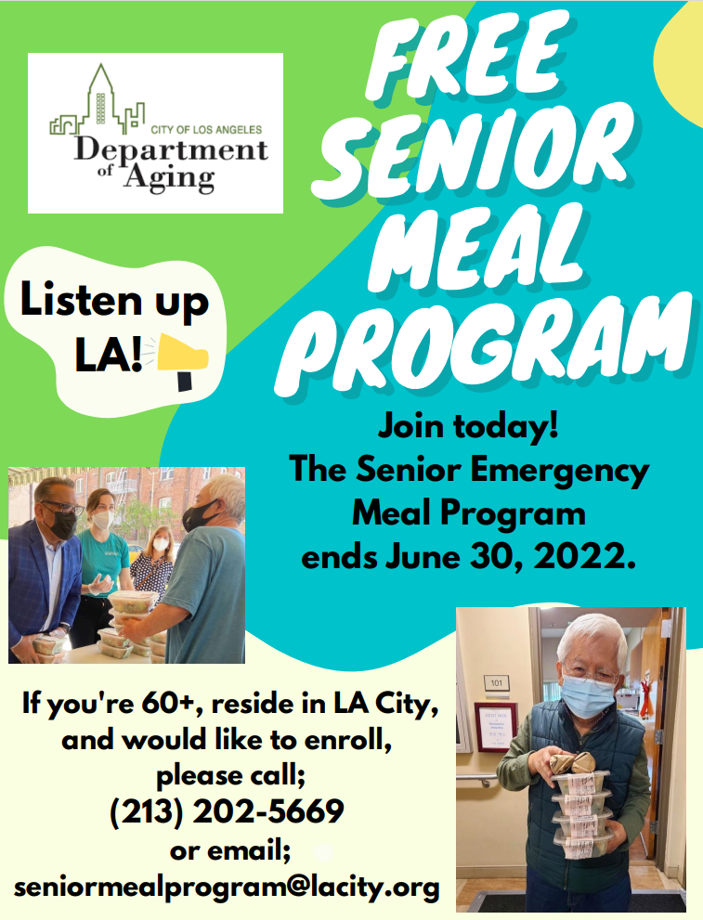
Public Comment - None
Committee Discussion – Theresa Torrance and Sylvia Wilson confirmed the extension of the program to June 30, 2022 and provided the contact information and procedure to sign up any eligible seniors 60 and above..

Public Comment on Non-Agenda Items - none
Adjourned: 8:15 pm
Next Meeting- June 9, 2022 at 6:30 pm.

