Community Services Committee
Chairperson Sylvia Wilson
Meeting Date: April 14, 2022 6:30 pm
Meeting Place Online

Call to Order: 6:33pm

Committee members in attendance: Sylvia Wilson, Teresa Torrance, Carey Begbie Westerfield

Other NC members: Cord Thomas, Naomi Waka

Discussion/Action (Motion):

1.
Approval of Minutes from March 10, 2022 Meeting.
Teresa - made motion Carey - 2nd motion

2.
Discussion with Achee Stevenson, Senior Director, Programs, St. Joseph’s Center on St. Joseph’s Housing Assistance, Job Training, and VHOP programs.
Presentation by Achee Stevenson, St. Joseph’s founded 1976, main housing program is rental assistance and subsidy, successful partnership with building developer for shared housing (separate bed and bathroom but shared common areas), first PRK site opened in April 2020 as Covid prevention, PRK sites are being turned into PHK sites, act as on-site service providers, offer web development training and culinary training program, still operate PRK in Venice (44 people) but closing this summer
VHOP - vehicular homeless outreach program in SPA 6 but can assist in SPA 5, able to dispose inoperable vehicles and subsidies for housing, RV dwellers don’t consider themselves homeless and are resistant to other housing, they need something equal (in terms of privacy) to be motivated to move, want hotel for short term or individual housing for long-term, harder for outreach to engage with this group, want to hold on to their RV so RV storage is important, Ballona RVs don't want to go to Safe Parking program that accepts large vehicles because its too far away
Let City Council member and Holly Mittchell know that we are in approval of a RV parking site in our area?
Ask Holly Mittchell to add a VHOP team to SPA 5?
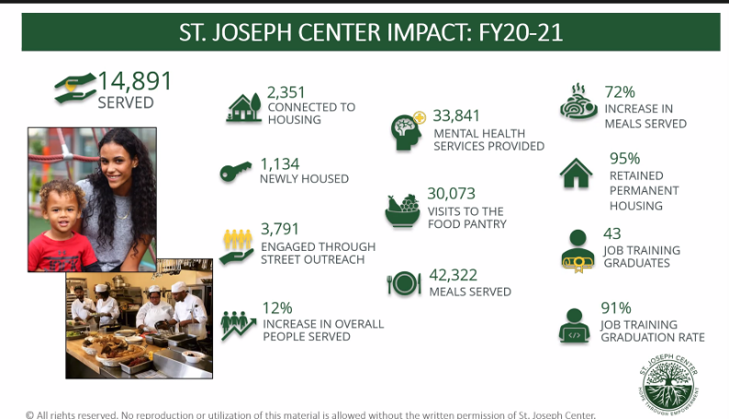
- Public Comment - Cord Thomas
- Committee Discussion - questions and comments by Theresa Torrance, Carey Begbie Westerfield, Sylvia Wilson (see notes above)

3.
Presentation and Discussion with Bill Morgan, Airport Marina Counseling Services, on Supporting Mental Health in our Community during the Pandemic.
Information from Bill Morgan: 60th anniversary, low cost mental health services to those that wouldn’t be able to afford normally (annual income less than $30K), have 50 therapists, individual and family and couple counseling, LGBTQ program, trauma intervention program (10 weeks long), training facility, at-risk kids program (referrals from WESM and OWMS and want to expand to more schools), teen group therapy to middle school Y members, 30% of funding is from clients, 30% from annual fundraising event ($300K), the rest is grants and private donations, besides NCWP no funding comes from gov’t, partnering with Peoples Concern to help recently housed folks
- Public Comment - Cord Thomas, Ahmanise Sanati
- Committee Discussion - questions and comments by Theresa Torrance, Sylvia Wilson

4.
Discussion with Elvina Beck, Chief Executive Officer, PodShare, on PodShare’s Co-Living Housing Model.
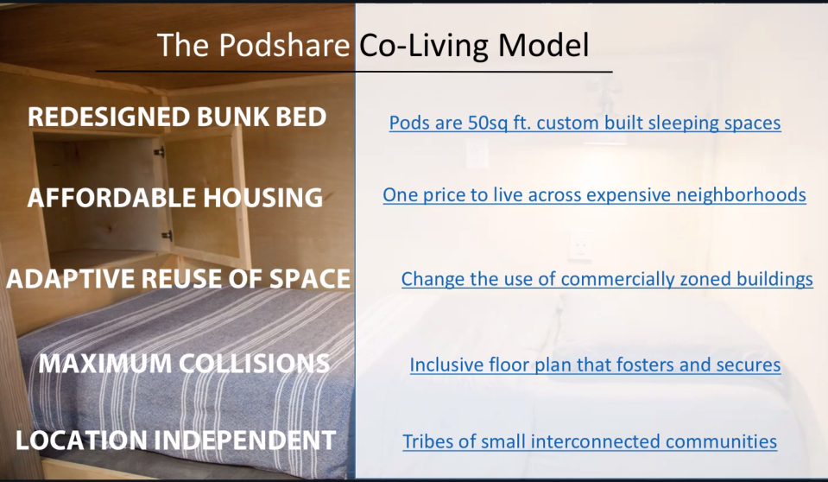
Presentation from Elvina Beck: Started in 2011, currently have 5 in LA / 1 SF / 1 SD, great use of space for temporary living, well-designed and aesthetically pleasing from commercial spaces, 100 sq foot per person, each personally space has 3 walls (with outlets, light, tv, stairs, bed, storage space), common sense policies, avg length of stay pre Covid was 3 weeks, avg length during pandemic is 3 months, low barrier to entry (no background check, no min or max stay, no proof of income, no security deposit), have non-profit partners (Safe Place for Youth, Hollywood Food Coalition, HousingWorks, DCSF), Podshare for Social Good (non-profit organization), $40 per night, Venice opened 5 years ago and have space for 50, every location has paid RA’s, food and toiletries are free for residents, 27-35 years old is average age of residents
- Public Comment - Ahmanise Sanati
- Committee Discussion - questions and comments by Theresa Torrance, Sylvia Wilson, Carey Begbie Westerfield

5.
Discussion and Possible Motion to Recommend Neighborhood Purposes Grant to Airport Marina Counseling Services of up to $2000.00.
Teresa - made motion Carey - 2nd motion
- Public Comment - none
- Committee Discussion - none

Public Comment on Non-Agenda Items - none
Adjourned: 8:20pm
Next Meeting- May 12, 2022 at 6:30 pm.

